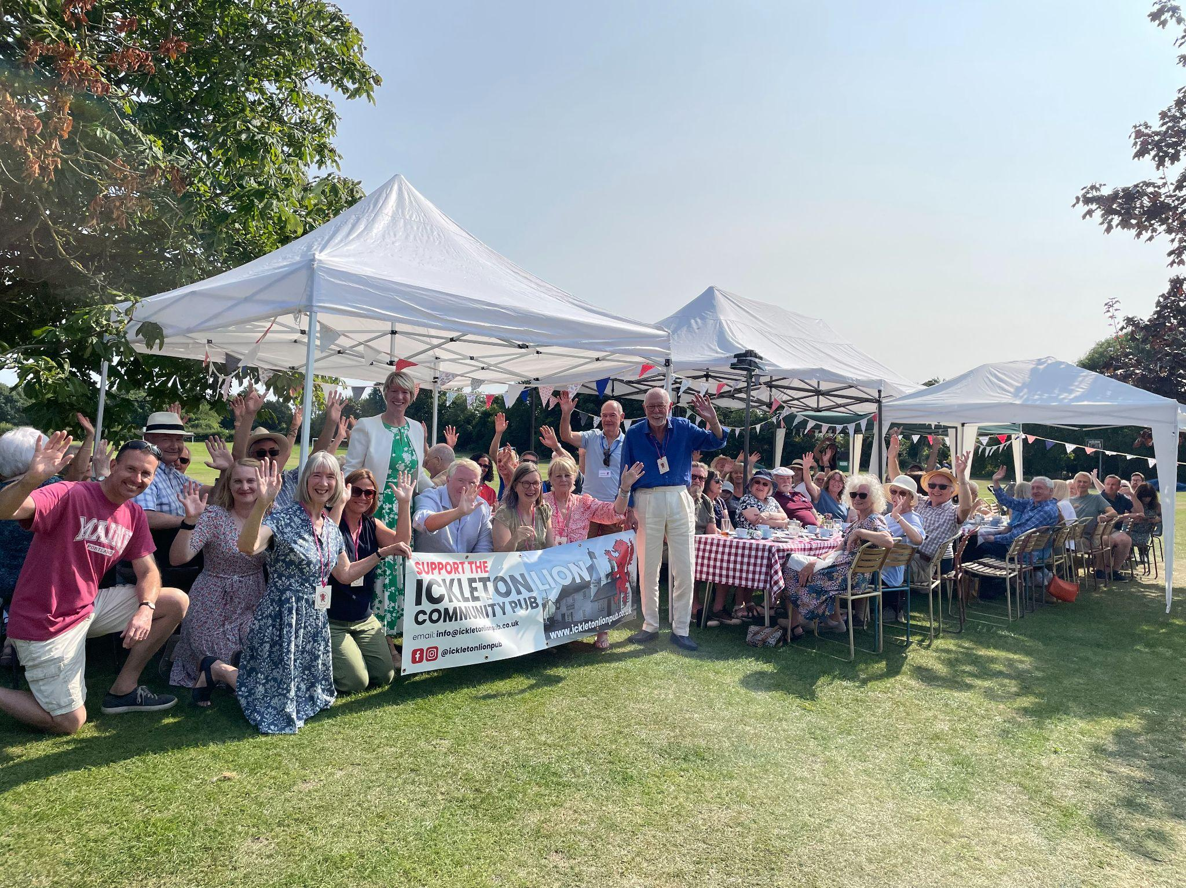
Ickleton Lion update
A big thank you to everyone who came along to our afternoon tea in August and Curry Night in September, including MP Pippa Heylings and Councillor Peter McDonald who joined us for tea.
A great deal of work goes on behind the scenes to make these events a success, so thanks also to everyone who cooked, lent us decorations and equipment and helped to set up and wash up.
Our next event is a ‘Mexican Fiesta!’ on 12th October - tickets on sale from Ickleton Costcutter and online at www.ickletonlionpub.co.uk
Campaign update
A HUGE thank you for your support for our campaign so far. As of 9th September we had over 350 members and were 86% of the way to our £450,000 target! Keep an eye on our website and facebook page to follow our progress.
We are delighted to have been awarded £45,000 funding from Cambridgeshire & Peterborough Combined Authority as part of its Market Towns Programme. The CPCA has partnered with Plunkett UK, to help community groups across the region take ownership and operation of local pubs and assets that are vacant or at risk of closure.

Both Plunkett UK & the CPCA have provided invaluable support for our campaign. Whilst this grant award does not reduce the amount of money we need to raise through the share offer, it is a very welcome contribution to the funds we will need to purchase and revitalize the Lion.
You may enjoy the video on our homepage - a quick skip through 300 years of the Lion’s history. Thank you to several Ickletonians and the fabulous Ickleton Society archive for all the memories.
www.ickletonlionpub.co.uk
info@ickletonlionpub.co.uk
@ickletonlionpub
@ickletonlionpub

